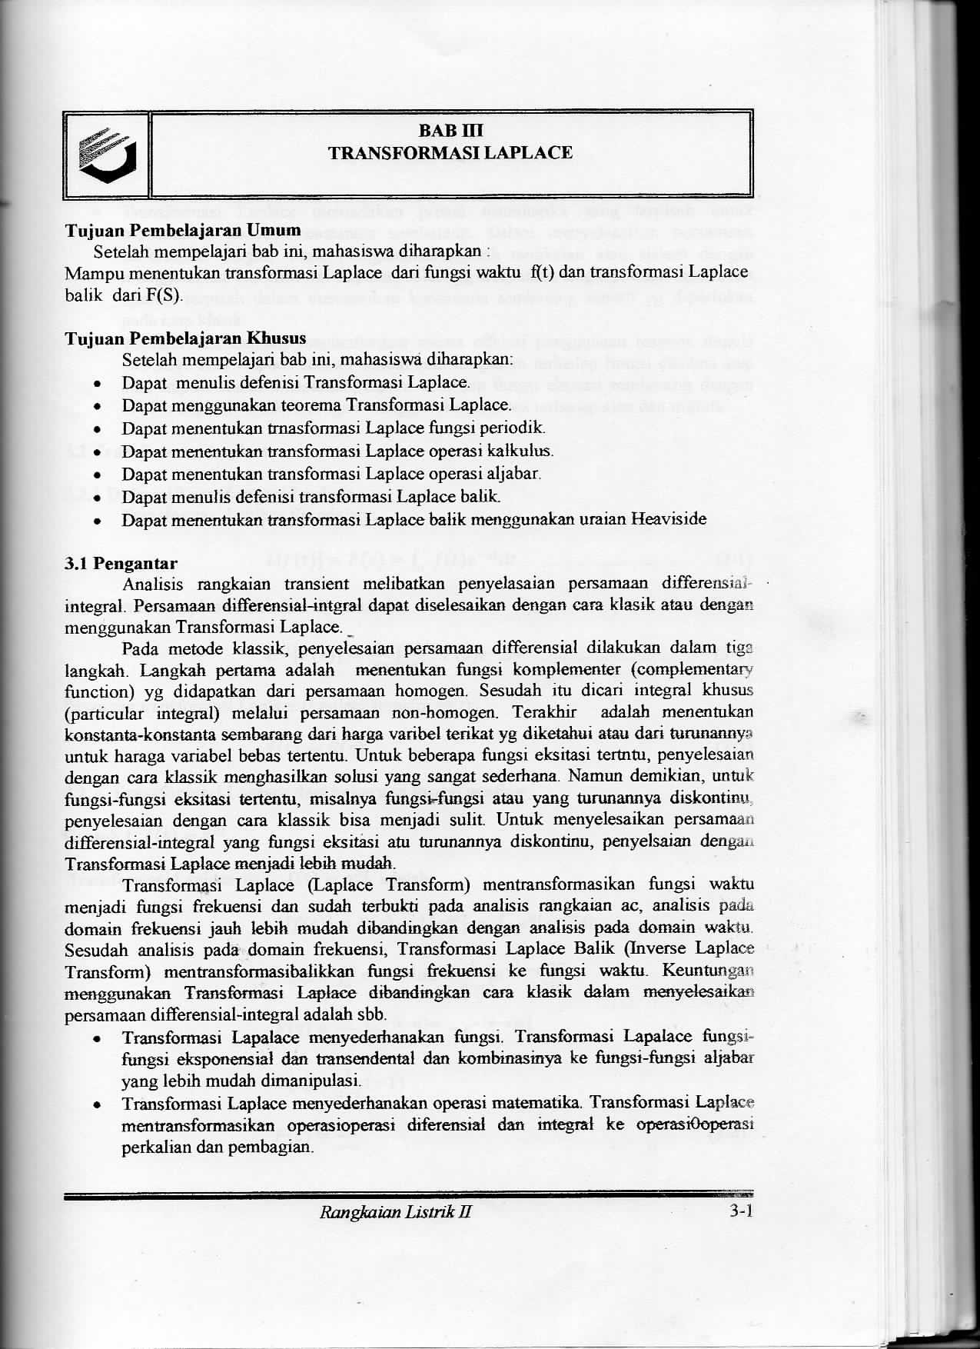

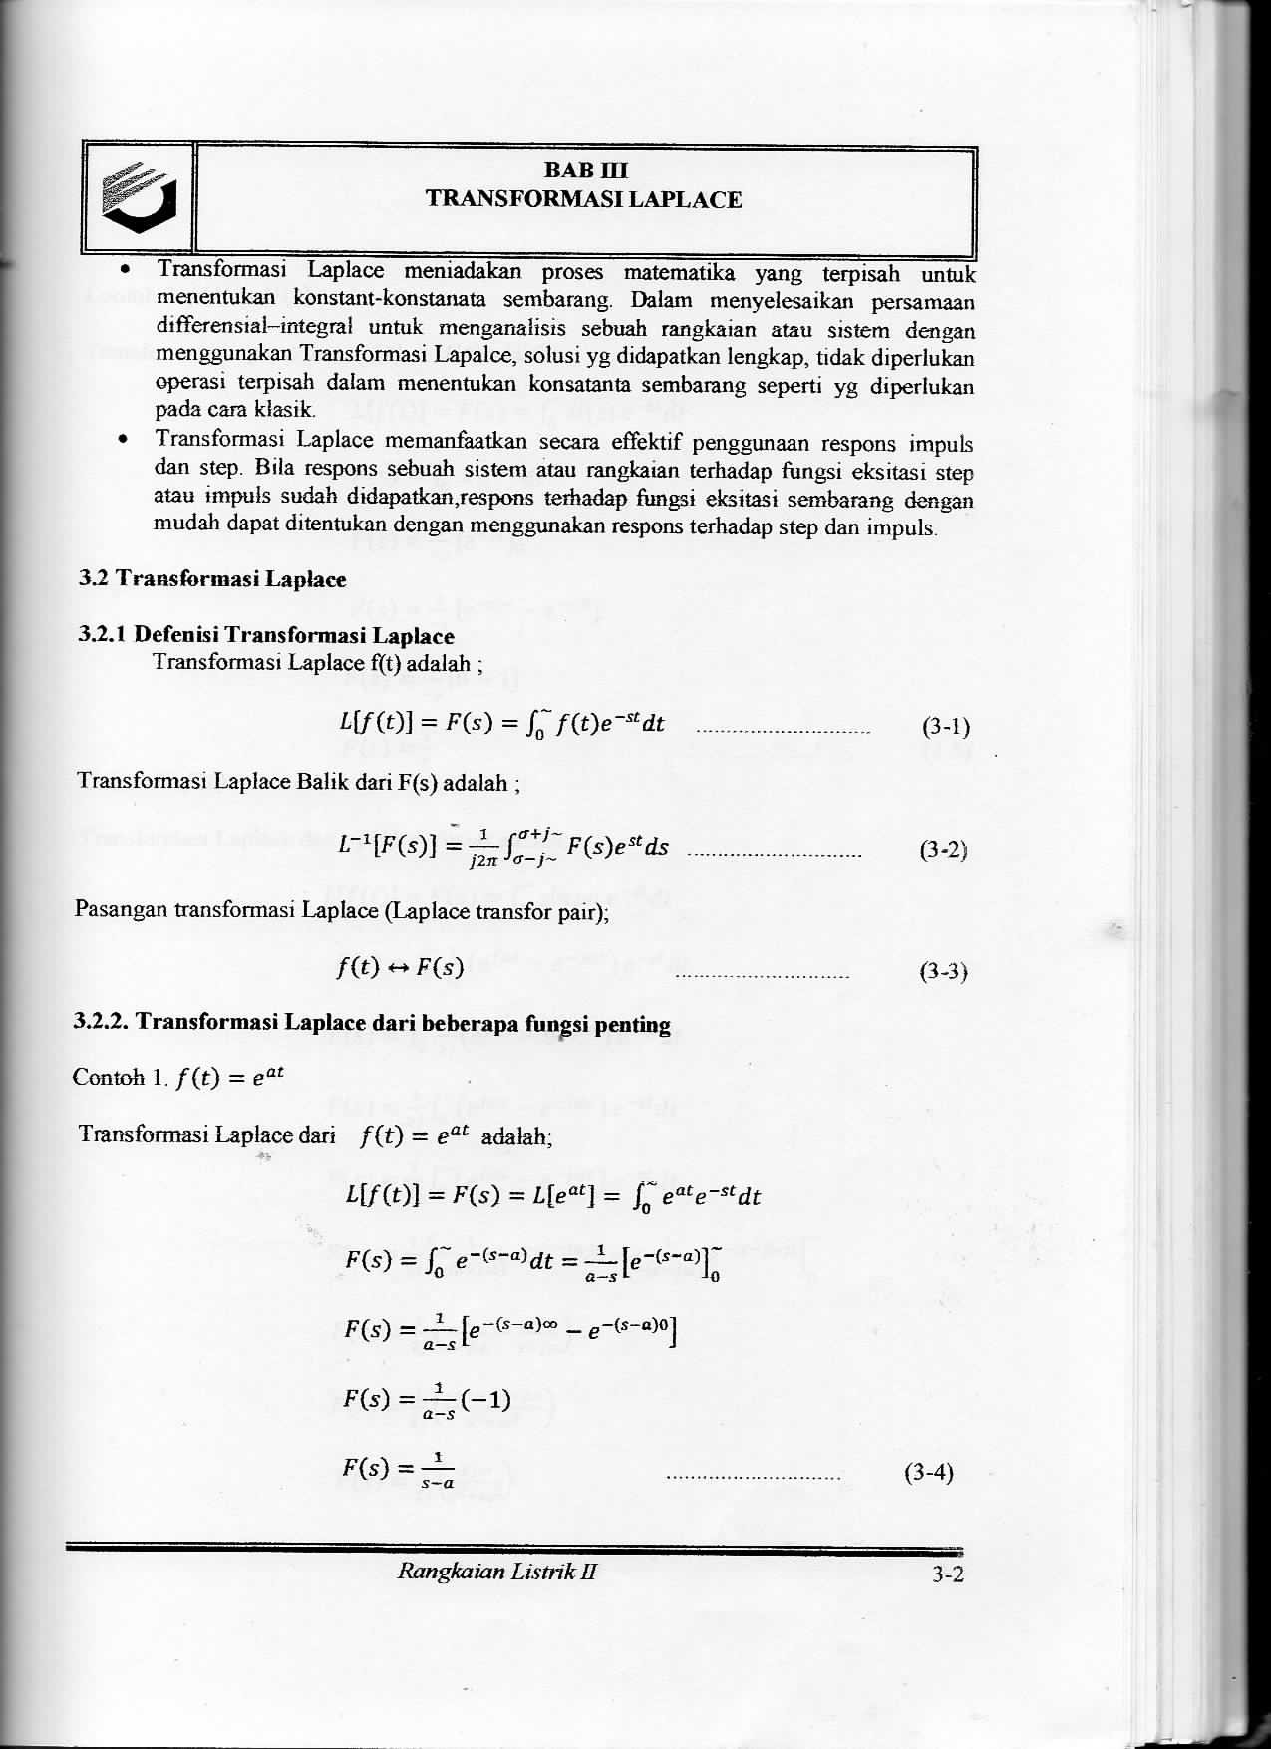
“In this chapter we will be looking at how to use Laplace transforms to solve differential equations. There are many kinds of transforms out there in the world. Laplace transforms and Fourier transforms are probably the main two kinds of transforms that are used. As we will see in later sections we can use Laplace transforms to reduce a differential equation to an algebra problem. The algebra can be messy on occasion, but it will be simpler than actually solving the differential equation directly in many cases. Laplace transforms can also be used to solve IVP’s that we can’t use any previous method on.
For “simple” differential equations such as those in the first few sections of the last chapter Laplace transforms will be more complicated than we need. In fact, for most homogeneous differential equations such as those in the last chapter Laplace transforms is significantly longer and not so useful. Also, many of the “simple” nonhomogeneous differential equations that we saw in the Undetermined Coefficients and Variation of Parameters are still simpler (or at the least no more difficult than Laplace transforms) to do as we did them there. However, at this point, the amount of work required for Laplace transforms is starting to equal the amount of work we did in those sections.
Laplace transforms comes into its own when the forcing function in the differential equation starts getting more complicated. In the previous chapter we looked only at nonhomogeneous differential equations in which g(t)g(t) was a fairly simple continuous function. In this chapter we will start looking at g(t)g(t)’s that are not continuous. It is these problems where the reasons for using Laplace transforms start to become clear.
We will also see that, for some of the more complicated nonhomogeneous differential equations from the last chapter, Laplace transforms are actually easier on those problems as well.”

